Proposal for   
**LIBRARY MANAGEMENT SYSTEM**

SUBMITTED BY- GROUP-12(Section-3)

|  |  |
| --- | --- |
| SARHAN OSMAN BHUIYA | 1611008042 |
| RABEYA SULTANA | 1531146042 |

NORTH SOUTH UNIVERSITY

Website: www.northsouth.edu

# Table of Contents

**INTRODUCTION………………………………………………………PAGE 3**

**USER STORY……………………………………………………………PAGE 3**

**SOLUTION DESCRIPTION…………………………………………PAGE 4**

**FRONT-END PLAN ………………………………………………….PAGE 5**

**BACK-END PLAN…………………………………………………….PAGE 5**

**DEVELOPMENT PLAN…………………………………………….PAGE 7**

**HOSTING……………………………………………………………….PAGE 7**

**PROJECT SCHEDULE……………………………………………….PAGE 7**

**INTERFACE DESIGN………………………………………………..PAGE8, 9**

# 

# Introduction

This is a library management system. This system is basically built for school, college and universities. Library plays are a vital role in any educational institute. This is a proposal of development of a universal digital portal for the betterment of students as well as teacher’s easy access to the library resources. Our system will be very much user friendly and very easy to navigate. Students usually do not have the idea about library resources in many universities as they are engaged with the internet in this 21th century and depend on online resources like PDF versions of book. Our system will be unique because it will allow users to get hard copy books as well as online soft copies.

# User Story

## Use Case 1:

Mr. Anik (Head of library management). He wanted to access the library management system. As he is the admin and head of activity so he has a different login apart from student. So it means it has two different login portal. One for student and one the head of library (admin).

## Use Case 2:

Mr. Anik(Head of library management). He needs to register new students in the library list of existing students. Using add feature, he can add new student in the library list. He will be able to sort the student according to their respective IDs and send notification for next level of activities to database to check for authentication of existing student ID matches or not.

## Use Case 3:

Mr.Anik wanted to book any student ID who has borrowed a book from library. Here the add feature will be used but in a different list of students who has borrowed the book.

## Use Case 4:

Mr. Anik wanted to search a book from the book list to see the amount of book available, to see the total amount of book and also to keep track so that the student who has borrowed the book has returned the book in due time or not.

## Use Case 5:

Suppose a student a lost a borrowed book or destroyed a borrowed book, then Mr. Anik has the authority to fine that student a certain charge and delete that book from the book list.

## Use Case 6:

Online soft copy of books will be available for students.

# Solution Description

## Architecture

For our database, we are using MySQL. MySQL are huge user base for such content like library management system and are easily accessible. These can handle large volumes of structured and unstructured data for easy use and object oriented programming.

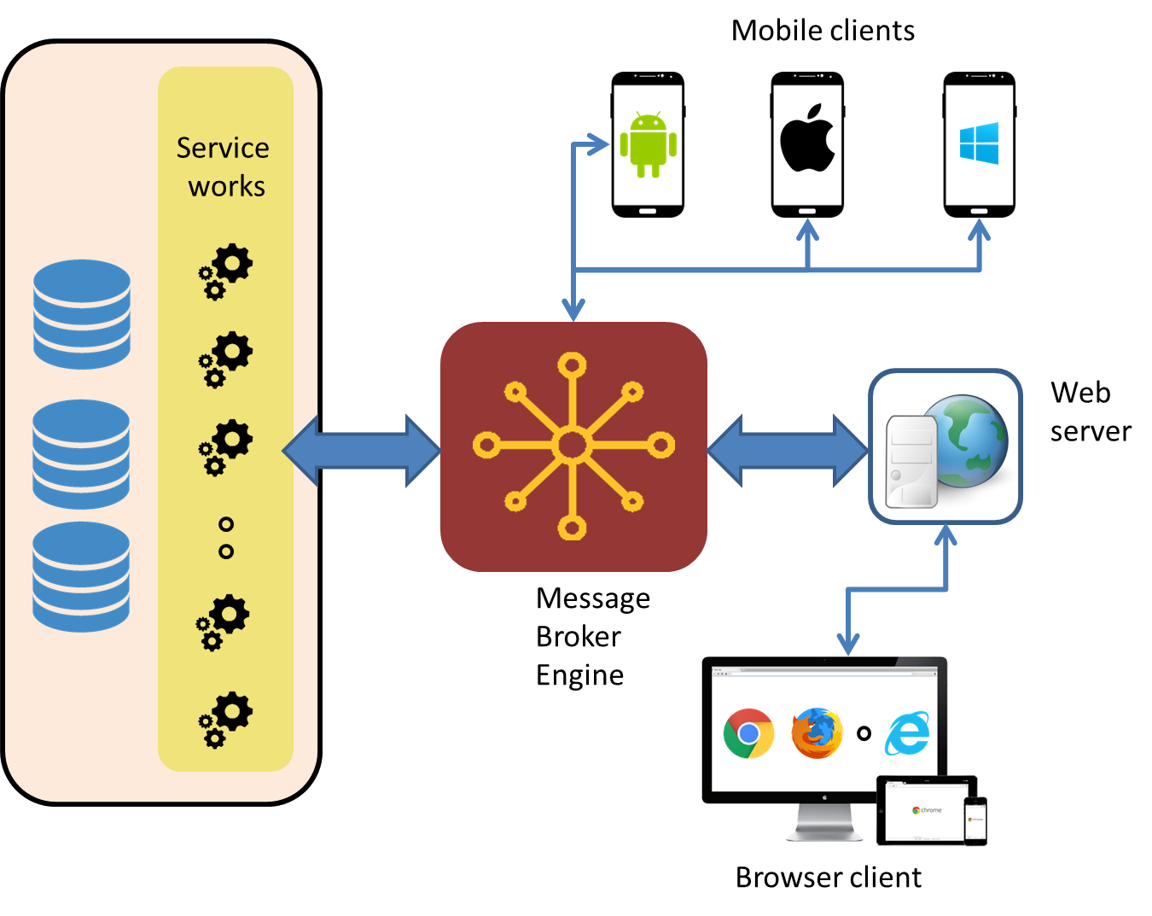



 

We are using raw PHP as our programming language. For designing or for frontend we are using CSS-3 and HTML-5 along with Bootstrap.

## 

## Front-end plan

A total of 6 page-templates in plan (as of April 30, 2019)

1. Home page along with contact details
2. Search result page
3. Book details page along with soft copy(pdf)
4. Student details page
5. Borrowed student list details
6. Register/login page

## 

## Back end development

1. Account Creating, Password Recover:
   1. Sign up form, verification by mobile or email.
   2. Login
   3. Facebook login
   4. Google login ( WE MAY TRY TO IMPLEMENT)
   5. Forgot Password
   6. MySQL Database
2. Student Profile Management:
   1. DB plan design and dev: MySQL
3. Searching facility:
   1. Total student registered
   2. Total books available
   3. Borrowed number of books
4. Add features and delete features

# Development Plan

Development methodology will adopt agile methodology. Each cycle will complete in exactly 2 weeks (10 working days). At the end of each cycle, we will release a working software version. We work on each section within the limited time. Our main goal will be to establish a workable website which will be easily accessible by our users.

## Phase 1

Duration: 1week

We shall design the front end part using HTML, CSS and Bootstrap.

## Phase 2

Creating a database in our localhost and connecting it to the database.

## Phase 3

Making connections between search function, add function and delete function using PHP.

# Hardware/Hosting Plan

We are planning to use our localhost to host our webpage.

# Project Schedule

Our project may take around 90days to complete which is 3 months. But it may be finishes before that.

Table 1: Schedule

|  |  |  |  |  |  |  |  |  |  |  |  |  |
| --- | --- | --- | --- | --- | --- | --- | --- | --- | --- | --- | --- | --- |
|  |  | **Days** | | | | | | | | | |  |
| **SL** | **Deliverable** | **18** | | **18** | | **18** | | **18** | | **18** | |  |
| 1 | Front end Development | - | - | - | - | - |  |  |  |  |  |  |
| 2 | Student Profile Management |  | - | - | - |  |  |  |  |  |  |  |
| 3 | Backend & Management |  |  |  | - | - | - |  |  |  |  |  |
| 4 | Search facility |  |  |  |  | - | - | - | - |  |  |  |
| 5 | Deployment and Final Release |  |  |  |  |  |  |  | - | - |  |  |
|  | **Total duration** | **18** | | **18** | | **18** | | **18** | | **18** | | **3months** |

# 

**INTERFACE DESIGN**

**HOME PAGE**

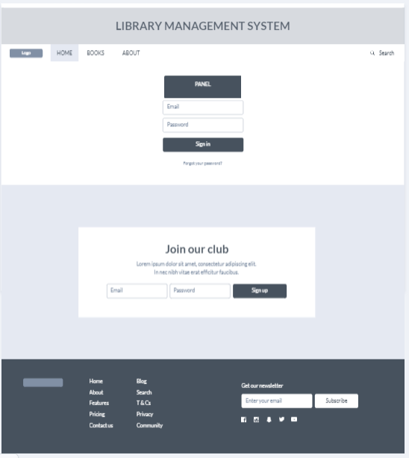

**BOOK PAGE**

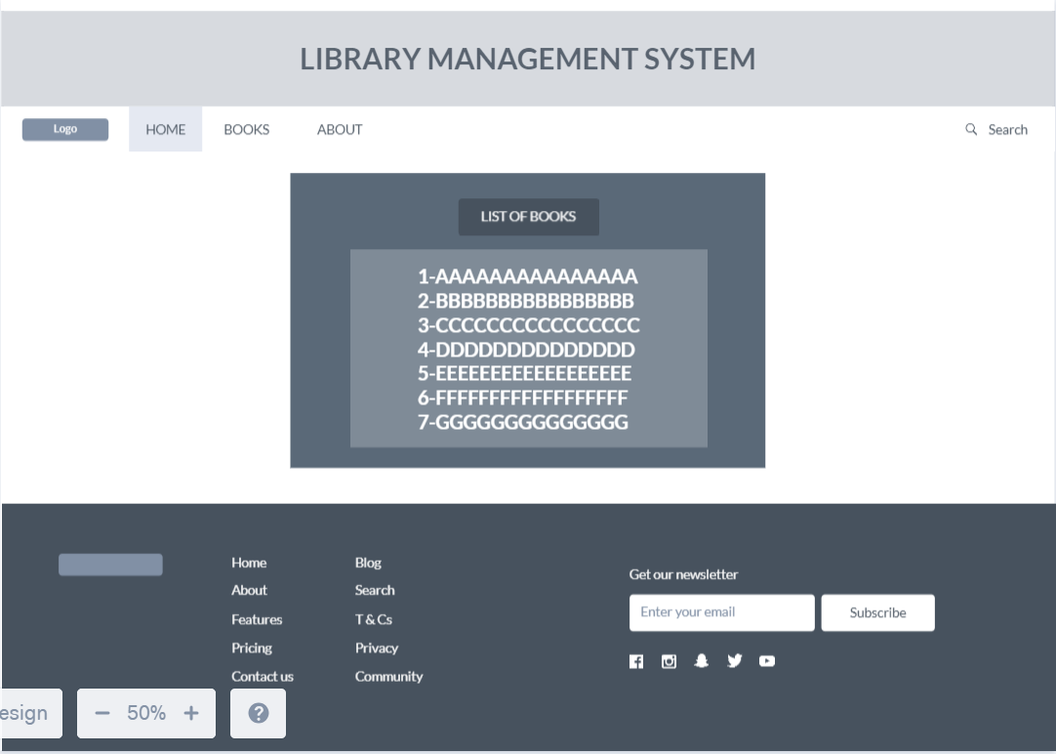

**ABOUT PAGE**

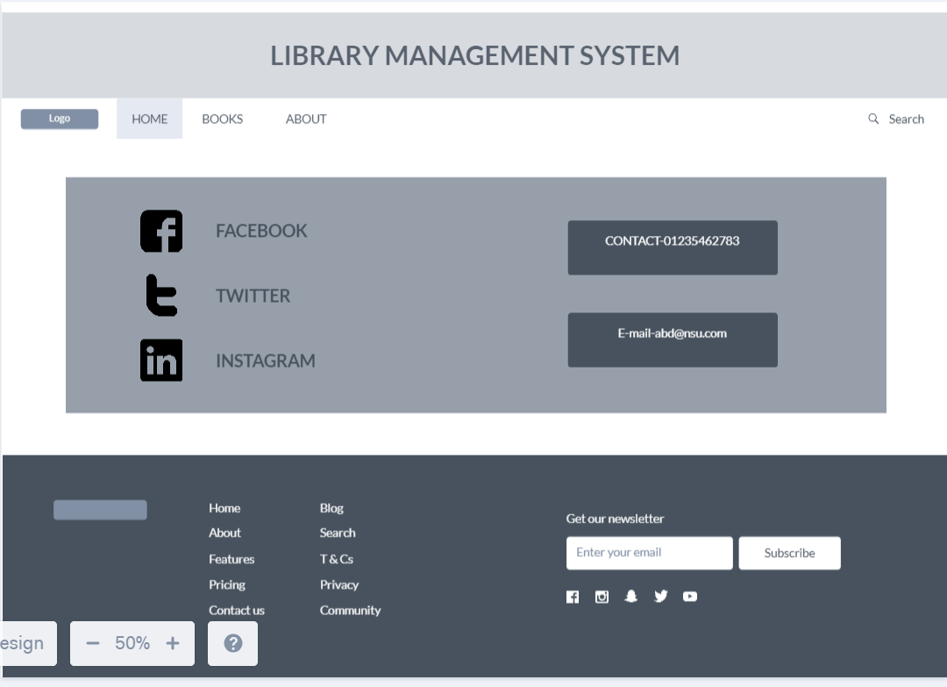

**STUDENT PANEL**

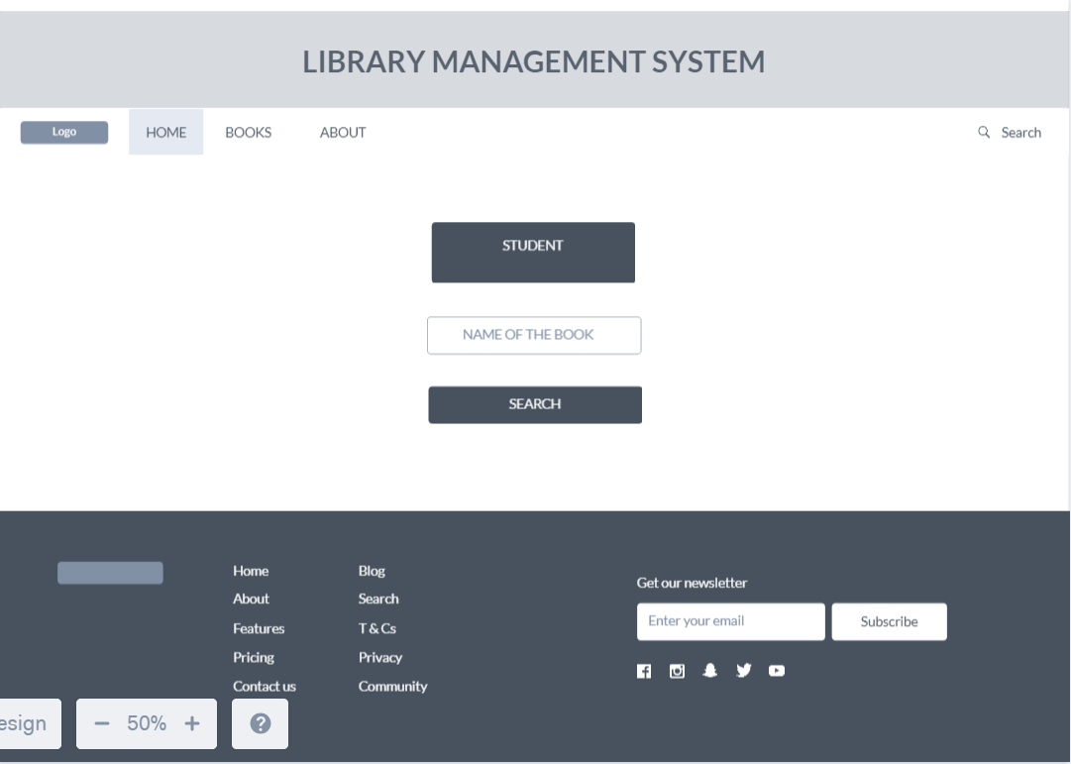

**ADMIN PANEL**

